# 

# How Blockchain Technology is Changing Real Estate January 11, 2022

[www.sahara.st](http://www.sahara.st)

founder@sahara.st

가로선

# 

**Contents**

### Abstract

1. Introduction to the Sahara Platform
2. How blockchain technology is changing the real estate industry
3. Sahara Platform Core Theory Overview
4. How to get to digital assets
5. Platforms and Marketplaces Description

# Fractional and frictionless real estate investing

1. Team members introduction
2. Sahara Site Map
3. Token Economics
4. How does SAHARA perform on Ecosystem?
5. Token Information
6. Lock policy
7. Road-Map
8. partner companies
9. Learn more about Tokenplace

### Abstract

Real estate is the largest asset class in the world. Commercial enterprises and real estate professionals are recognizing the transformative impact of blockchain technology to optimize retail and commercial property sales, streamline payments, and increase access to real estate funds and investment opportunities.

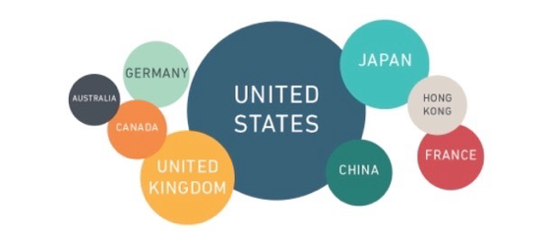



**Introduction to the Sahara Platform**

### 

### Sahara's goal is to provide a blockchain based software platform for real estate transactions that anyone can access and use easily and safely. We hope that this platform can bring value to our clients via enhancing the control and transparency to the clients.

### 

### The Foundation is located in the Republic of Malta, USA-based Sahara Street is responsible for global team operations and marketing, and Korea-based Sahara Street is responsible for technology development.

### 

[Sahara Resort operated by Sahara Platform]

**How blockchain technology is changing the real estate industry**

**Concept**

Sahara decentralized real estate platform revenue through value through sharing and segmentation.

Sahara Real Estate Platform Concept

As assets become digital, the value of real estate will also change significantly. Traditional real estate ownership was mostly single-person ownership. The Sahara Real Estate Platform is designed to generate more revenue through sharing and segmentation capabilities.

The platform ensures transactions through secure authentication when all ownership of digitized assets and contracts is transacted through the smart contract process.

The concept of real estate sharing means that many people own equity assets.

The concept of sharing means getting rewarded when more people engage through social networks.

A segmentation node is defined as an AG (Agency) on the Sahara platform.

Value dissemination marketing through Real Estate License Brokers (AGs) operating in the Americas, Europe and Asia offers many members the opportunity to participate. It aims to be the Amazon of digital asset platform.

The current real estate valuation method (price) will go beyond our thinking in the future, and real estate prices will be created in a new way through the Sahara platform.

**Sahara Platform Core Theory Overview**

In the face of the digital economy, it seems that assets can be invested in real estate. Many investors are showing a lot of interest in the price of real estate in the future.

In the digital economy, the price of real estate will affect the real estate market such as housing due to various variables.

Among them, the key is to select representative predictable variables and examine which variables affect the real estate price and how much.

The Sahara platform is to establish a model for determining real estate prices empirically.

In order to predict the future real estate market such as housing through the Sahara platform, the simulation of the independent variable index will precede.

**Effect of Variables**

In the traditional real estate market, the price of a Real Estate Value (Vt) usually is based on standard variables as follows:

• L: Land Value

• B: Building and Apparatus Value

• R: Revenue Producing Value such as Lease and Use Value

Therefore, the Real Estate Value in the traditional market can be expressed in the following equation:

Vt = L+B+R

However, the Real Estate Value in the digital market (Vd) will be influenced by additional factors in comparison to the traditional Real Estate Value (Vt).

One must consider the following additional factors:

• N: N represents the contribution of the total number of Real Estate Brokers/Agents (N). In Sahara Street’s case, we shall call it “Sahara Node” represented by “N” in the below equation.

• F: F is an important factor, which represents the value that will be brought by “Followers” of the Brokers/Agents, meaning their customers and collaborators. This F shall be called “Node Follower”, and this number reflects the market demand that can affect the value, meaning the higher demand leads to a higher overall value, Vd. In addition, the Node Follower will also be rewarded based on their contribution in the process, which gives them incentives for higher motivation.

• I: I depict the value introduced by Investment in the digital market

• X: X is a variable that affects the above-referenced factors based on market conditions, including the location of the property and the average condition of the digital market. X is introduced, in order to adequately reflect the market fluctuation of the digital market as well as the value-added by “sharing” and “digitalized asset” in the digital market.

**Value Prediction**

Therefore, one can express the process of predicting the value of a real estate property in the digital market in the following manner:

Vd = Vt + (N*F*I)*X

In comparison between the traditional real estate and digital market, if a real estate property is digitalized, then it is obvious that the digitalized asset shall have the additional path to incorporate the market demand and interest, which explain in “N”, “F” and “I” in the above mathematical expression.

**How to get to digital assets**

**CREATING VALUE THROUGH DATA**

The sharing economy ecosystem of digital assets and technical challenges for segmentation

**①**Smart contracts

Smart real estate contracts enabled by blockchain will not only speed up the leasing process and save on costs, but it can also improve due diligence. Blockchain would have the ability to verify identities and incomes, and reduce the likelihood of fraud.

②Transactions

The entire real estate transaction process can be held on the blockchain. The submission of an offer, verification of title, the acceptance and verification of that offer, the due diligence process, the financing, and closing can all be verified and codified within a digital ledger. The use of blockchain for real estate transactions has significant implications for real estate agent and broker jobs.

③Financing

Credit checks, income and identity verification, debt to income ratios, and so much more can be held on and verified using blockchain. The mortgage financing process is fraught with friction and frustration. If all your critical documents are held on blockchain, no longer do you need to scramble to get dozens of different documents to your bank or broker.

④Land titles

Traditionally kept offline, blockchain tech has the ability to store and verify these critical l[egal real estate documents](https://www.fool.com/millionacres/real-estate-market/real-estate-innovation/how-find-out-who-owns-property/). Imagine if you could log into a blockchain land registry to verify title ownership of any plot of land in your area.

⑤Leasing

Identity verification and contracting signing can be facilitated and held on a blockchain. Whether it’s income verification of the tenant, employer checks, or other references, this can all be facilitated and held on a digital ledger.

⑥Liquidity

If an asset becomes tokenized to 1,000 investors instead of 10, you automatically increase the liquidity of that real estate investment. If buyers and sellers of tokens are more easily able to sell and buy shares in a particular asset, then exit strategies and liquidity problems drop significantly.

⑦Ownership

A real estate blockchain can be used as a single source of truth to verify ownership of assets. This includes fractional ownership through a token, and all the owners of those tokens will be publicly available.

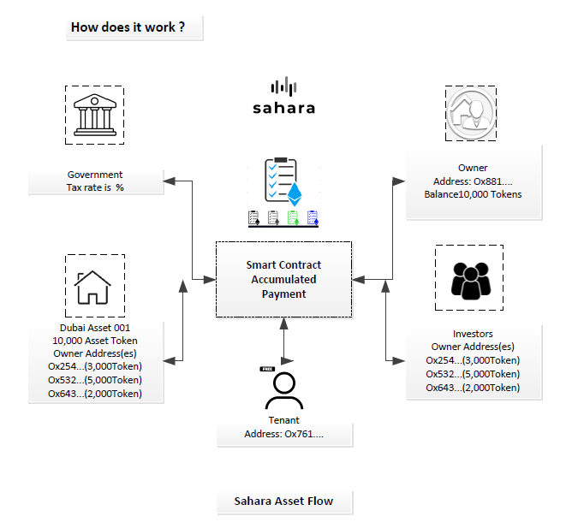

[Diagram -A]

**Platforms and Marketplaces Description**

Platform and Market Description

**1. Platform and Market**

Real estate technology has traditionally been primarily concerned with listing and connecting buyers and sellers. However, blockchain introduces new methods to real estate transactions and enables trading platforms and online marketplaces to support real estate transactions more comprehensively. For example, Sahara is developing a platform that uses blockchain technology to facilitate real estate transactions. By tokenizing real estate, assets can be traded online on exchanges.

The Sahara platform allows sellers to tokenize their assets and use the platform to liquidate their assets through token sales. The collected tokens can be exchanged for fiat currency through the platform by sellers and buyers who own the assets.

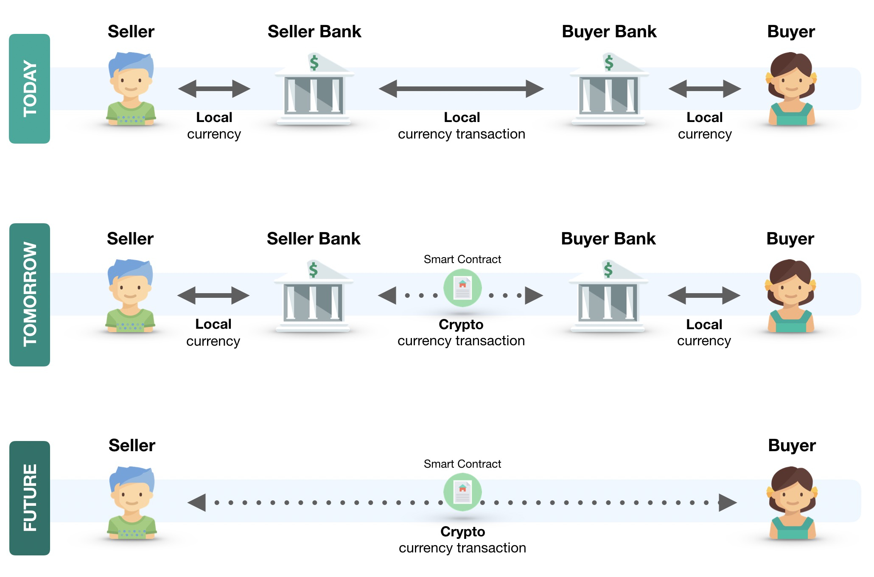

[Diagram -B]

<**The source** [https://github.com/NorbanDev/RealEstate2.0](https://github.com/NorbanDev/RealEstate2.0?ref=hackernoon.com)>

**2. No Intermediaries**

Brokers, lawyers, and banks have long been part of the real estate ecosystem. However, blockchain may soon usher in a shift in their roles and participation in real estate transactions, according to a report by Deloitte.1﻿ New platforms can eventually assume functions such as listings, payments, and legal documentation. Cutting out the intermediaries will result in buyers and sellers getting more out of their money as they save on commissions and fees charged by these intermediaries. This also makes the process much quicker as the back-and-forth between these middlemen gets cut.

KEY TAKEAWAYS

Blockchain technology has impacted the real estate industry in a variety of ways, including offering a new means for buyers and sellers to connect with one another.

Blockchain could be used to cut intermediaries out of the real estate transaction process, thereby reducing costs.

This technology could also help to codify the practice of fractional ownership of real estate.

**3. Liquidity**

Real estate has long been considered an illiquid asset since it takes time for sales to conclude. This isn’t the case with cryptocurrencies and tokens since they can, in theory, be readily traded for fiat currencies through exchanges. However, as tokens, real estate can be readily traded. A seller doesn’t have to wait for a buyer who can afford the whole property in order to get some value out of their property.

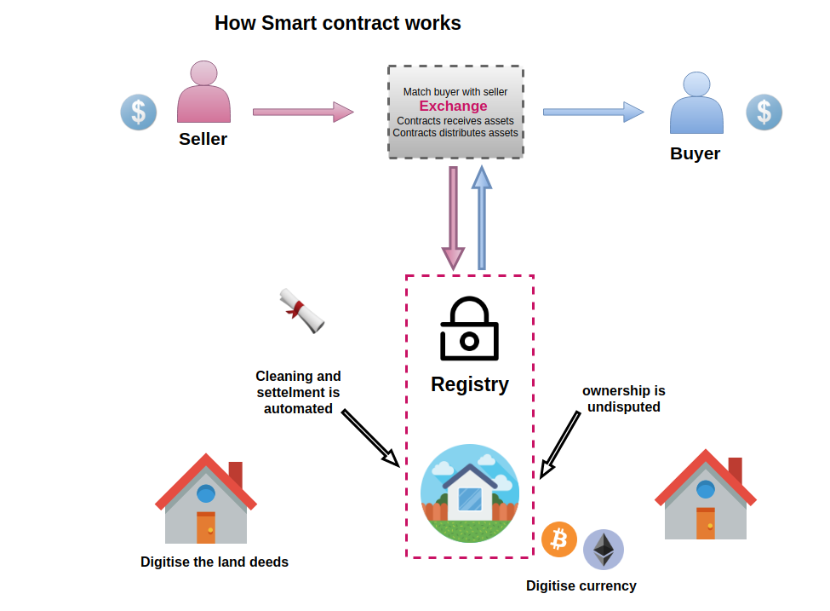

[Diagram -C]

**4. Fractional Ownership**

By allowing fractional ownership, blockchain also lowers the barriers to real estate investing. Typically, investments would require significant money upfront in order to acquire property. Alternatively, investors could also pool their money to acquire bigger ticket properties. Through blockchain, investors would simply have to access a trading app to buy and sell even fractions of tokens as they see fit. In addition, fractional ownership would also help them avoid managing the properties themselves such as maintenance and leasing.

Upkeep alone can add up to significant costs and dealing with tenants may be a troublesome effort. This also affects related activities such as lending where property owners often have to put their properties as collateral for loans in order to get quick access to cash. Depending on the terms, property owners may also continue enjoying use of their property.

**5. Decentralization**

Blockchain commands trust and security as a decentralized technology. Information stored in the blockchain is accessible to all peers on the network, making data transparent and immutable. One only has to go back to the housing bubble crash in 2008 to see how greed and the lack of transparency in the part of institutions can have catastrophic consequences. A decentralized exchange has trust built into the system. Since information can be verifiable to peers, buyers and sellers can have more confidence in conducting transactions. Fraud attempts would also be lessened. Smart contracts are increasingly becoming admissible records with Vermont and Arizona passing such legislation. As such, smart contracts would have more enforceability beyond the technology itself.

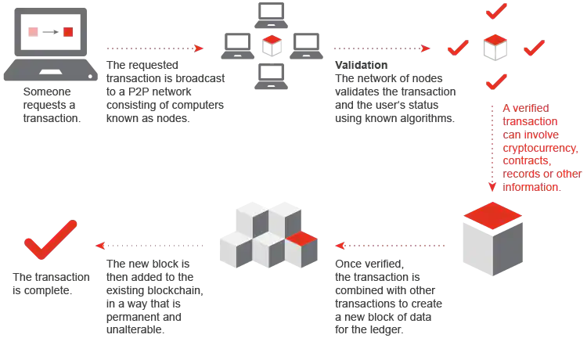

[Diagram -D]

**6. Costs**

The transparency associated with a decentralized network can also trim down costs associated with real estate transactions. Beyond the savings made by cutting out intermediaries’ professional fees and commissions, there are other costs such as inspections costs, registration fees, loan fees, and taxes associated with real estate. These costs even vary depending on the territory that has jurisdiction. Like intermediaries, these can be reduced or even eliminated from the equation as platforms automate these processes and make them part of the system.

Global real estate is worth hundreds of trillions of dollars, but is dominated by the wealthy and large corporations. Through blockchain technology, it is possible that more people will be able to access the market where transactions can be made more transparent, secure, and equitable. Real estate transactions may eventually become truly peer-to-peer activities with blockchain-powered platforms doing most of the work.

# Fractional and frictionless real estate investing

###### OWNERSHIP REINVENTED

For the first time, investors around the globe can buy into the Dubai real estate market through fully-compliant, fractional, tokenized ownership. Powered by blockchain.

KYC/AML

In order for the sale of SaharaTokens to be compliant with applicable regulations, purchasing a SaharaToken through the Sahara website will require the implementation of “know your customer”(KYC) and anti-money laundering (AML) procedures. Sahara is implementing KYC procedures to verify the identities of our SaharaToken purchasers and AML procedures to ensure that payments for

SaharaTokens do not come from illegal sources. Sahara is implementing AML/KYC solutions through IdentityMind, an independent third-party solutions provider.

**Investment Status**

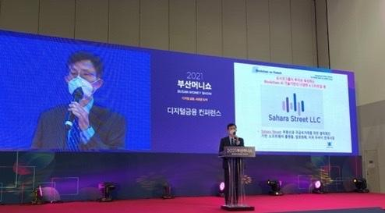

**[South Korea Busan Money Show - November-2021]**

**U.S Silver Class Venture Capital USD$3,000,000 Series A Seed Secured**

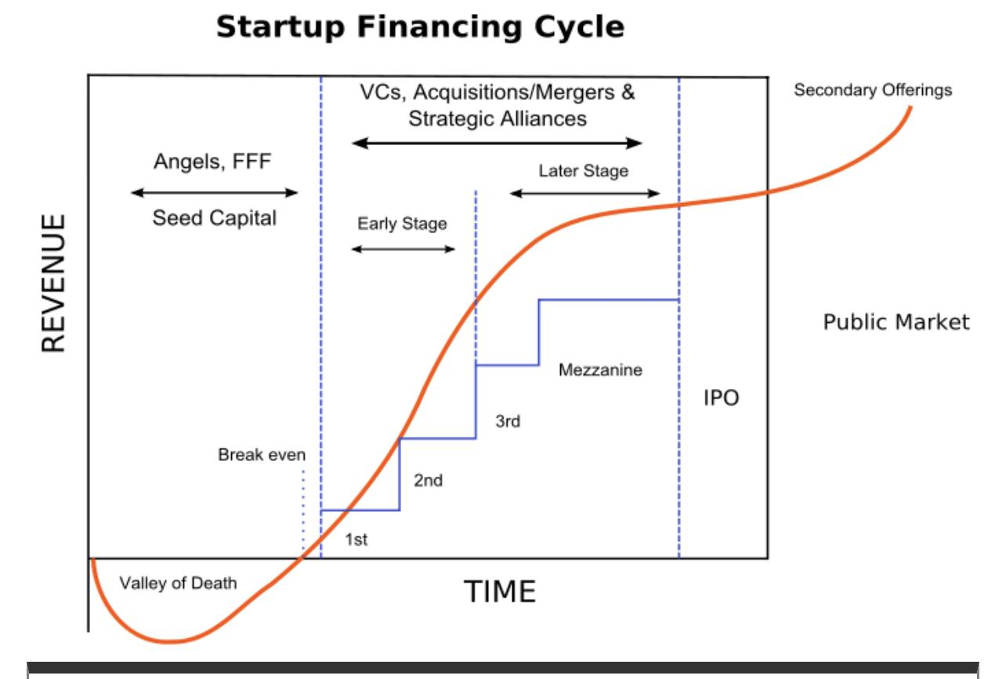

[Diagram -F]

**Team members introduction**

| ①  Dr. Han Ko |  | Co-Founder & Ceo |
| --- | --- | --- |

https://www.linkedin.com/in/han-ko-3b8814185/

* Startup and investment experience in various technology and real estate fields such as Founder, President & CEO, USAKO Group, etc.
* Director and Chairman of the Steering Committee, AACC Chamber of Commerce board member profile
* Official Director, Board member of St. Louis County, Missouri, USA. Louis County, Missouri, U.S.A., Commission Board
* State of Illinois, State of Illinois, FVHT Metro East Business Incubator Board Member
* Mentor, Technology and Investment Advisor Capital Innovators, a venture capital company
* Chief Technology Officer (CTO), [Watch Skin](https://watchskins.com/) (a high tech software wearable)
* Global Marketing Director/Founder [Native Agtech](https://www.gonative.ai/) (AI driven consumer perf. mgmt)
* Adviser/Investor/Mentor Roles in various technology and investment companies and enterprises including [WIF AX](https://wifaxvc.com/qoz-fund#) (a $50M+ Morgan Stanley managed investment Fund), [Trailyn Ventures](https://trailyn.com/) (tech accelerator and investment),[Native Agtech](https://www.gonative.ai/company) (B2B AI platform), [Watch Skin](https://watchskins.com/), SoleNTek (a high tech IP manufacturing), Union Mobile (an international telecom), [DawinKS](http://www.udawin.com/?act=info.page&pcode=info04) (a Fintech & high tech Software Dev.), [Delta Tech](https://deltatech.tech/index.php/about/) (a high tech consumer electronics), [Blockchain Accelerator](https://trailyn.com/), zPODs, zBONEs, VoiceXP (a Voice Recognition & AI), and Liker World (an international blockchain), [Emerge One Medical](https://www.emergeonemedical.com/about-us) (PPE & Medical Supply) and other companies.
* A Judge, Mentor and an Advocate for Arch Grants (A Venture Capital Grant Program)
* Editor of the investment magazine Entrepreneur Quarterly, Investor's Magazine EQ editor in investment
* Director and Steering Committee Chair FIRST Robotics, a Board Member and Steering Committee Chair (FIRST Robotics Association, USA)

| ②  Barbara Bickham |  | **CTO****Global technical engineer****NFT,Blockchain,** |
| --- | --- | --- |

https://www.linkedin.com/in/barbarabickham/

#### 

#### Blockchain, Investment, Tech Scale-up

* Blockchain, Investment and CTO professional
* Morgan Stanley managed fund WIFAX
* $50M+
* Computer Science & MBA
* U. of California, Berkeley

| ③  **Yeom Ki Ho** |  | **CTO/Korea Dev’** |
| --- | --- | --- |

CEO Keystone Lab & KDEX Cryptocurrency Exchange -CEO

Hanbit Academy Java Programming Bible Author-Bestseller

Metaverse, NFT, blockchain expert

Programming lectures on C/C++, VISUAL C++, JAVA, VB, etc.

**Representative of the ICT Technology Association**

| ④  Brian Jung |  | Co-Founder |
| --- | --- | --- |

https://www.linkedin.com/in/jungminho/

**New trend future forecasting expert**

* Brian Jung, Co-Founder and research director of sahara street LLC, created the world's first Internet Network Center (~93'). It is the beginning of internet cafe and pc bang. Introduced the G4c e-Government solution for the first time, and has a number of patents related to blockchain, AI, and IoT.
* Blockchain, AI, and IoT architecture experts [Blockchain and Metaverse patents]

### [Seoul National University Graduate School of International Studies GLP mba completion](https://www.linkedin.com/search/results/all/?keywords=Seoul%20National%20University%20Graduate%20School%20of%20International%20Studies%20GLP%20mba%20completion)

* Completed a Fintech course at the Dongguk University of Seoul, South Korea.

| ⑤  George Wu |  | Dr. GT Wu, Ph.D & J.D, Exec. Director |
| --- | --- | --- |

https://www.linkedin.com/in/georgetatungwu/

#### 

#### Graduated from Cornell University, Stanford University, and University of California, Berkeley, where he received his Ph.D., Master's and Bachelor's degrees.

| ⑥  Collin Knock |  | Exec. Director |
| --- | --- | --- |

https://www.linkedin.com/in/collin-knock-b90a8a8/

RE Lending, Financing, Blockchain

* REFinancing and Reverse Mortgage, Blockchain, Investment expert
* Founded and operated one of top 100 financing co's in USA
* Founded and operated in multiple successful tech and financing ventures

| ⑦  Tom Ray |  | Exec. Director |
| --- | --- | --- |

https://www.linkedin.com/in/tom-ray-3947526/

Exec. Director

C-Suite Commercial Real Estate. Juris Doctorate

* Executive Level Licensed Commercial Real Estate Professional with Rich Market Experience and a Law Degree
* Award Winning Power Broker & REIT experience
* Senior VP CBRE, an international RE firm
* Juris Doctorate U.S.A.

| ⑧ **David Shim** |  | **Software Development**  Exec. Director |
| --- | --- | --- |

https://www. [linkedin.com/in/david-shim-08ab38b9](https://www.linkedin.com/in/david-shim-08ab38b9)

**Software Development Engineering at a high tech a boutique software consulting firm based in Denver, Colorado**

* **Experience in software development projects for multinational companies such as Amazon**
* **Accounting and Business degree from U. of Illinois, Urbana-Champaign and experience**

| ⑨  **Frank Pica** |  | **Exec. Director****Fund Raising and Product Development** |
| --- | --- | --- |

https://www.[linkedin.com/in/frankapica](https://www.linkedin.com/in/frankapica)

* **High Tech Based Product Development, Fund Raising and Marketing (Artificial Intelligent Product and Blockchain for C-Suite Companies)**
* **Explosive Growth in LockerDome in US and Adyoulike in Europe (Highly Successful Technology Based Marketing Companies) as a Founding Member and VP**

| ⑩  **Perry Chappell** |  | **Advisor** |
| --- | --- | --- |

#### 

#### https://www. [linkedin.com/in/perry-chappell-6496816](https://www.linkedin.com/in/perry-chappell-6496816)

#### 

#### **A successful startup founder and strategist for Exits and M&As**

#### 40 Years of experience with a focus on Consumer Markets and Startup Strategies

#### Multiple Exits and M&As:

#### • Founding team of NASDAQ trading company, Genesis Microchip

#### • VIXS - TSX

#### • Sale of VIXS to Pixelworks

#### • Genesis Paradise Electronics

#### • Genesis Sage

#### • Current CEO and Co-founder, Zing Communications Inc (U.S. and Canada) in 5G Entertainment ICT Service in very high speed for Verizon, T-Mobile, AT&T

#### 

#### 

| ⑪  Dr. H.E. Ko |  | MD, Executive Director |
| --- | --- | --- |

#### 

https://www.linkedin.com/in/eunice-ko-69176b65/

#### 

#### Investment, Medical Doctor, Tech Scale-up

* Medical Doctor
* Real Estate Investment
* Fund Management
* Tech Scale-up

| ⑫  Jae Kim/ |  | Exec. Director |
| --- | --- | --- |

#### 

https://www.linkedin.com/in/jae-kim-1b843b165/

#### 

#### Finance, Accounting, Risk Analysis

#### 

* Finance & Accounting, a chamber of commerce in U.S.A
* Fund Raise & Investment
* Private company Finance & Risk Analysis
* U.S. Bank, Credit & Risk Analysis

| ⑬  Yong Hyoung |  | Exec. Director |
| --- | --- | --- |

https://www.linkedin.com/in/yonghyoung/

Tech Scale-up, Startup

* Founder of "Cyworld"
* Quoted Proven Leader in Asia
* "The person who inspired Facebook"
* Korea Advanced Institute of Science and Technology
* (KAIST University, top high tech University in Korea)

| ⑭  Hyug-soon Kwon |  | Head of Fintech Center, KB Kookmin Bank (former)  TECHNO MBA (KAIST University, Korea's best high-tech university) |
| --- | --- | --- |

http://www.segye.com/newsView/20151126003573?OutUrl=naver

| ⑮  **Jason H. Jang** |  | Advisor |
| --- | --- | --- |

https://www**.**[linkedin.com/in/jason-h-jang](https://www.linkedin.com/in/jason-h-jang)

* **Tnc Group /CEO Co-Founder**
* **Master Degree, University of Michigan**

**Sahara Site Map**

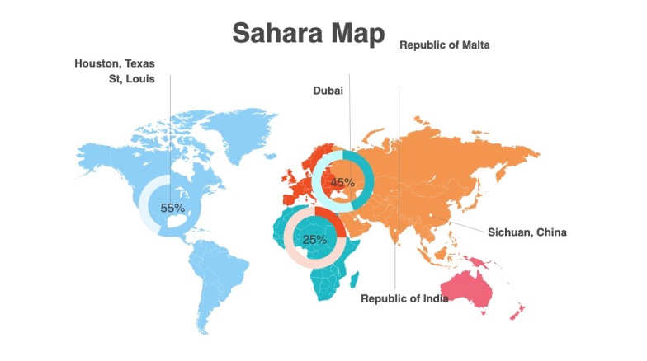

**Token Economics**

SAHARA Token is a governance token that aligns incentives across all stakeholders including users, SAHARA Token token holders, non-profit beneficiaries, the core team, advisors and partners. Below is the distribution of the SAHARA token:

SAHARA Ecosystem refers to the total amount of tokens reserved for , incentives and grants. These incentives and grants are specifically for users of SAHARA' DeFi products, and those who make valuable contributions to the protocol.

**Early Contributors** refers to supporters who funded development and operations to build out SAHARA

**Team** refers to core contributors.

**Partners/Advisors** refers to organizations and individuals who help SAHARA develop and evangelize the product and vision.

**Foundation** refers to the organization committed to bootstrapping the development of the SAHARA smart contracts, driving decentralization, onboarding non-profit beneficiaries, and ensuring the values of the SAHARA Foundation charter are upheld by all beneficiaries.

**Airdrop** refers to SAHARA token transfers for further decentralizing and rewarding the SAHARA community.

**How does SAHARA perform on Ecosystem?**

A new Real Estate and Gold asset class

Investors around the world are trending towards allocating significant capital towards investments that are socially conscious, sustainable, and responsible. SAHARA has not been created to serve those people, but a protocol and culture have emerged that puts people, the environment, and social responsibility first.

Environment:

A portion of SAHARA's fees is directed towards tackling global environmental challenges via smart contracts. In this way, environmental responsibility is encoded into the heart of the protocol.

Social:

SAHARA values diversity, inclusion, and decentralized decision-making. SAHARA contributors are women and men from diverse backgrounds, from all major continents, religious backgrounds, and ethnicities. Not only does the SAHARA culture support these values internally, but through the decentralized beneficiary governance and funding mechanism of the protocol, it ensures that underrepresented and disadvantaged groups have increased access to opportunity through the power of DeFi.

Governance:

The SAHARA governance model is decentralized and is not majority controlled by any one person. It is consistent with a fair and democratic decision-making process and the forthcoming charter outlines the values and inclusive decision-making framework for the protocol and organization.

Conclusion

While the initial token mechanics for the SAHARA token might be subject to change, the SAHARA team could not be anymore excited to roll out a tokenomic model that aligns incentives, promotes decentralization, helps automates key smart contract operations and works to inspire and ignite positive global impact through DeFi.

**Token Information**

Token Name : SAHARA

Symbol : SAHARA

Protocol : Bep20 Binance Smart Chain/ Utility token

Contract Address :0xb6adF5b4046583F836ce4FD71D7bAe7c68001288

Decimals: 18

Token Logo : 

Total supply : 3,000,000,000 SAHARA

Circulation supply :1,000,000,000 SAHARA

Origin country : Republic of Malta

|  |  |
| --- | --- |

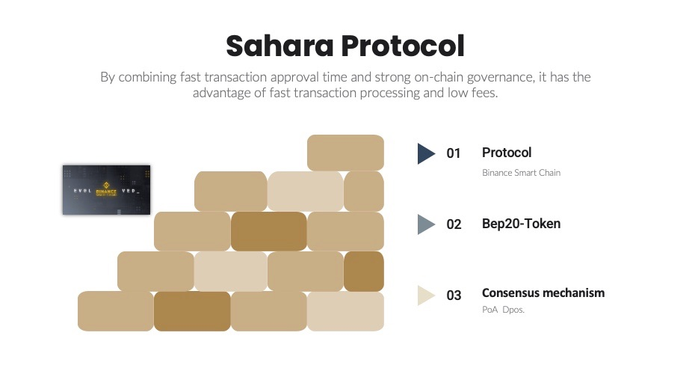

| Circulation supply  Development 21.0%  Team & Advisor 10.0%  Foundation 12.0%  partner companies 10.0%  Marketing 19.0%  sale & 28.0%    **Lock policy**  **Total Supply 2,000,000,000 SAHARA -5 years**  **Circulation 1,000,000,000 SAHARA**  **Development.21%**  After 1 year, 10% termination every 3 months  **Team & Advisor .10% /**After 1 year, 10% termination every 3 months  **Foundation** .**12%** **/** 3 years Lock  **partner companies .10%/**After 2 years, 10% term every 3 months  **Marketing.19% /**After 1 year, 10% term every 3 months  **Exchange Listing and Sale. 28%. /** Lock step by step after 6 months Unlock |  |
| --- | --- |

**Road-Map**

2021.

Q1 Al Khoory Group in Dubai Agreement

(www.premiumservices.ae)

- Q2

Sahara street LLC USA Global Office Open

Fyndus LLC in USA agreement-500,000 Members

-Q3

Hancom Group South Korea Agreement

Participated in Blockchain Conference - Chicago, USA

Participated in Blockchain Conference - New York

Blockchain Conference - South Korea 21’ Money Show

Keystone Lab- DEX Exchange Agreement

-Q4

USAKO Group USA -Venture Capital & Accelerator Seed USD$3,000,000 Agreement

Listing Exchange Agreement

-Aladdin25 Exchange in Dubai

2022.

Q1

Sahara Resort Open

2018 KoreanWinter Olympic Town

Solomon Capital Japan (remittance - Japan Financial Services Agency

approved company)

Sahara Korea Ltd Open -Dev’

Q2

Sahara Platform Launching

Q3

Metaverse & NFT Launching

-With Keystone Lab & KDEX Cryptocurrency Exchange

Global Real Estate Agent Marketing

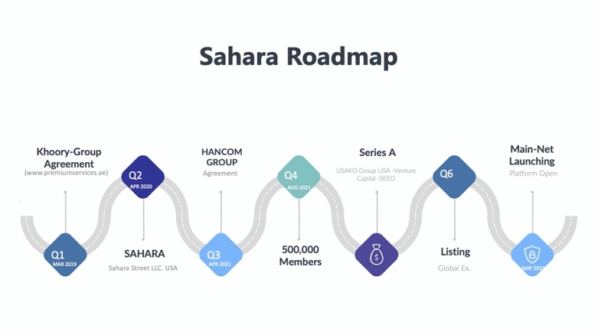

**partner companies**

**USAKO Group venture capital**

**-**International venture capital investment firm based in the US and Korea

**CryptoWorld**

**-**Education, mining, investment, OTC in the US-based cryptocurrency market

Franchise company that provides various services such as trading

**Fyndus Ltd**

**-**E-commerence and financial data based in the US and India markets

Software Platform Company for Management (Big Data)

**Watch Skins**

**-**Launched a blockchain-based NFT product based in the United States. Awarded as an excellent company at CES

**Native Agtech**

**-**Ai Blockchain Software-based Customer Satisfaction Small Based in the United States software evaluation platform

**Trailyn Ventures**

-U.S.-based blockchain technology and marketing education, before corporate incubation company

**Hancom Group**

**-**A company specializing in blockchain technology and gold and real estate based in Korea

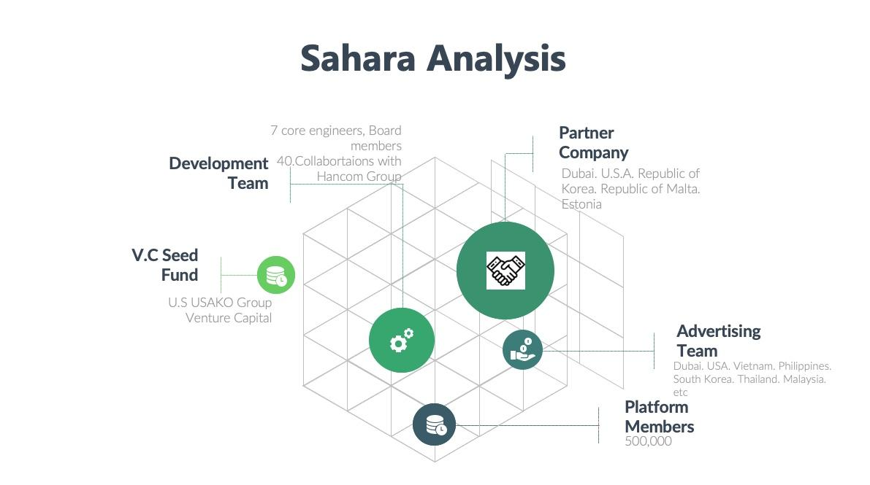

**Learn more about Tokenplace**

● Website: [https://](https://tokenplace.com/)www.sahara.st

● Telegram: https://t.me/likerworld

[https://t.me/](https://t.me/tokenplace)saharaofficial

* **https://github.com/SaharaStreetPlatform**
* [**https://medium.com/@sahara-street-news**](https://medium.com/@sahara-street-news)
* [**https://www.linkedin.com/in/sahara-street-llc-b18007213/**](https://www.linkedin.com/in/sahara-street-llc-b18007213/)
* **https://www.twitter.com/platformsahara**
* info@sahara.st

**------------------------------------------------------------------------------------------------------------------------------------**

ARTICLE SOURCES

Deloitte.com. "Blockchain in commercial real estate: The future is here," Accessed March 22, 2020